Model, View, Presenter in Animator’s Pal
Other names for this pattern:
- Data/View/Monkey (as in: monkey in the middle),
- Data/View/Arbitrator,
- Data/View/Facilitator

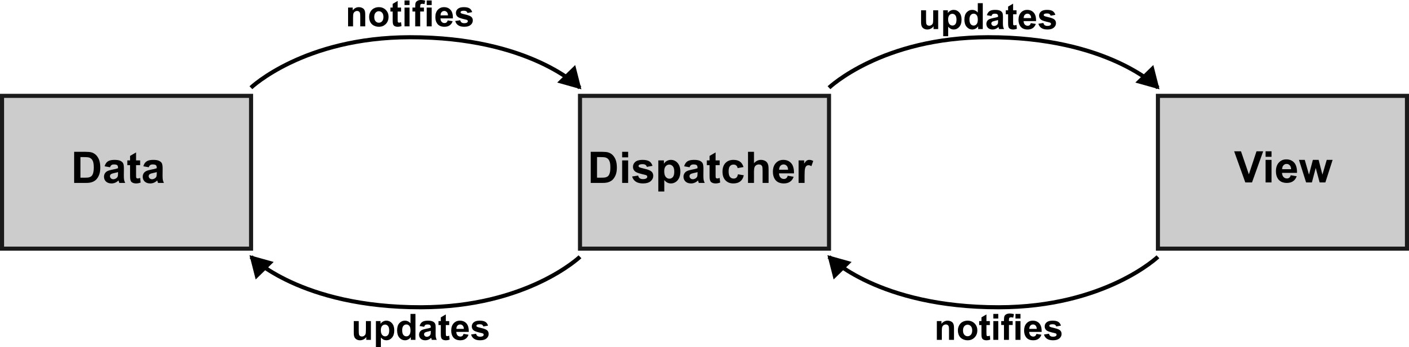

Data
- the APImageCollection class is a model,
- loads images from disk,
- converts between OpenCV, Pillow, and TkImage formats,
- show image method

View
- video canvas,
- control buttons

Dispatcher

__init__ args:
- model,
- view

__init__ responsibilities:
- bind button actions (view) to actions (model)

